39.30: a) The uncertainty in the particle position is proportional to the width of 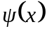, and is inversely proportional to 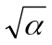. This can be seen by either plotting the function for different values of , finding the expectation value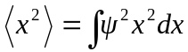 for the normalized wave function or by finding the full width at half-maximum. The particle’s uncertainty in position decreases with increasing . The dependence of the expectation value 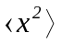 on may be found by considering
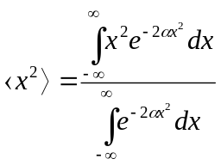
=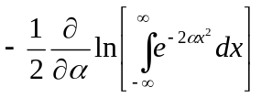
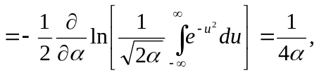
where the substitution 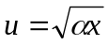has been made. (b) Since the uncertainty in position decreases, the uncertainty in momentum must increase.

